Review and Progress

Research on the Historical Origin and Development of Pearls
Zhu Di ¹ Jin Lingfei ^{2*}
1 Cuixi Academy of Biotechnology, Zhuji, 311800; 2 Institute of Life Science, Jiyang College of Zhejiang A&F University, Zhuji, 311800
* Corresponding author, jinlingfei@molplantbreed.org
Abstract Pearl is one of the earliest jewelry used by humans. In the eyes of ancient people, pearls were the most beautiful treasure. Due to the lack and low level of gemstone processing technology at that time, pearls were the only gemstone variety that shone brightly without the need for polishing. Their natural and beautiful characteristics established the important position of pearls in jewelry products. This review explores the historical origin of pearls and the important position of pearls in culture through myths and legends, analyzes the natural formation process and geographical distribution of pearls, elaborates on the development process of the pearl industry, and looks forward to the sustainable development of pearls in the future based on the current situation, providing important support and guidance for better utilization and protection of pearl resources.
Keywords Pearl; Historical origin; Sustainable development

Since ancient times, diamond, ruby, sapphire, emerald, jade and pearl have been hailed as the “five kings and one queen” in the jewelry world, and have been favored by people. Pearl is indeed like a lady with a graceful demeanor, with its noble status, gorgeous appearance, elegant demeanor, and pure character, quietly satisfying people's love of beauty. According to geologists, a large number of shellfish began to proliferate in the Triassic period 200 million years ago. Only with shellfish can pearls be born. As for when and where humans first discovered and used pearls, we have no way to investigate. What we can know is that since the moment it was discovered, humans have been fascinated by its natural beauty, not only treating it as a gift from heaven, worshiping it as a god, but also treating it as a symbol of wealth and luxury. Preferring pearls is the unanimous choice of people of different skin colors in the world. The history of pearl gathering by different races in the world is as long as their culture.Tracing back, the history of harvesting natural pearls has been at least thousands of years long.

Pearl is a gemstone with important cultural and economic value, which has been paid attention to and pursued by people since ancient times. Pearl has unique aesthetic value and historical significance, and is an important part of human civilization. In ancient times, pearls were once considered a luxury, and only royal nobles had the opportunity to own them. Today, with the development of the pearl industry and the continuous progress of technology, pearls have become a common ornament and have been widely recognized and loved in the world.

This review will explore the historical origins and development of pearls and review relevant research. By introducing the historical origins of pearls and explaining the development of pearls, the current status and trends of pearl research are discussed. Finally, the history, development and research of pearls are summarized, and the trends and prospects of future pearl research are discussed. Through the research and summary of this article, we can better understand the history and cultural background of pearls, as well as the current status and development trend of the pearl industry. At the same time, this article summarizes the research on pearls in biology, culture and society, providing strong support for the development of the pearl industry and the inheritance of pearl culture.

1 The Historical Origins of Pearls
1.1 Myths and legends of pearls
Pearls have different legends and myths all over the world, which reflect people's awe and praise for pearls, and also express their yearning and pursuit for the mysterious and magical power of pearls.

In traditional Chinese culture, pearls are called "dragon balls", which are believed to be the tears of dragons. According to legend, dragon balls have magical powers that can help people fulfill their wishes, eliminate diseases, and drive away evil. Therefore, dragon balls are regarded as a symbol of auspiciousness and mystery in Chinese culture and are widely used in art, culture, religion, etc.

The story of the pearl maiden is recorded in the Japanese mythology "Kojiki". The pearl-lustre is a goddess in Japanese mythology. She emits a pearl-like light and is considered the goddess of pearls. According to legend, the pearl maiden once gave her pearls to humans to help them overcome disasters. Therefore, the pearl maiden is regarded as a symbol of kindness and goodness in Japanese culture.

In Indian mythology, there is a story called "Pearl Necklace". It is said that the Indian goddess Lakshmi once wore a necklace made of pearls, which is considered one of the most beautiful treasures in the world. According to legend, the pearl necklace has magical powers that can bring good luck and happiness to the wearer. Therefore, in Indian culture, the pearl necklace is seen as a symbol of power, wealth and beauty.

The story of the pearl tear is recorded in Homer's epic "Odyssey" in ancient Greece. According to legend, the pearl tear is a pearl given by the sea god Poseidon to the daughter of the sea god. The pearl tear has magical powers that can keep people young and beautiful. Therefore, in Greek culture, the pearl tear is seen as a symbol of love and beauty.

1.2 The symbolic significance of pearls in myths and legends
Pearls have been given different symbolic meanings in various myths and legends, including power, beauty, purity, mystery and magic. These symbolic meanings reflect people's awe and praise for pearls, and also express people's yearning and pursuit for the mysterious and magical powers that pearls possess.

In Chinese and Indian cultures, pearls are regarded as symbols of power and status. In ancient China, dragon pearls were considered tears of the dragon, and those who wore them were believed to possess the power and status of the dragon. In Indian mythology, the pearl necklace worn by the goddess Lakshmi is also seen as a symbol of power and wealth.

In Japanese and Greek mythology, pearls are seen as symbols of beauty and purity. In Japanese mythology, the Pearl Shine Maiden is believed to be the goddess of pearls, and her pearl-like radiance represents purity and beauty. In Greek mythology, pearls are regarded as symbols of the goddess of love, Aphrodite, representing the power of beauty and love.

Pearls are seen as symbols of mystery and magic across various cultures. In Chinese mythology, dragon pearls are believed to possess mysterious powers that can help people eliminate diseases and ward off evil. In Japanese mythology, the pearls of the Pearl Shine Maiden are believed to have magical powers that can grant people's wishes and bring good luck. In Indian mythology, the pearl necklace of the goddess Lakshmi is also believed to have magical powers that can bring wealth and good fortune.

1.3 The historical origins of pearls
The history of pearls can be traced back to around 2300 BC in China, where pearl-bearing mollusks were considered as jewelry and luxury goods (Sha and Zhang, 2013). In ancient times, the main sources of pearls were concentrated in the coastal areas of the Indian Ocean and the Red Sea, such as the Persian Gulf, the Arabian Sea, and the Indian Peninsula. Ancient merchants brought pearls to Europe and China through the Silk Road and maritime trade. In Europe, pearls have become collections of noblility and royalty, while in China, they became essential accessories for wealthy women.

In Japan, the history of pearls can be traced back to the Yayoi period, around 2000 BCE. At that time, Japanese people began using pearls as decoration and gifts. The rise of the Japanese pearl industry dates back to the late 19th century, when Japanese fishermen discovered a large number of pearl oysters, making pearls an important export commodity for Japan.

Due to their rarity and value, pearls were once an extremely expensive commodity that only the wealthy and aristocrats could afford in ancient times. However, with the development of the pearl industry and constant advancements in technology, pearls have become a common accessory and are widely recognized and loved around the world.

2 Natural Formation Process and Geographic Distribution of Pearls
Pearls are organic substances formed in the shape of a bead by the secretion of mollusks. They are a type of natural gemstone (Zhang, 2006). The natural formation process of pearls is very unique and involves several stages, including secretion by the mollusk, invasion by foreign objects, encapsulation by the pearl sac, and formation of the pearl substance. It takes several years or even decades for a complete pearl to form.

The distribution of pearls is mainly concentrated in tropical and subtropical regions, including the Pacific Ocean, the Indian Ocean, the Persian Gulf, the Mediterranean Sea, and the Red Sea. Among them, the Pacific Ocean is the world's largest pearl-producing area, including Japan, the Philippines, Indonesia, Australia, and other countries. Pearls from the Indian Ocean and the Red Sea are mainly produced in India, Sri Lanka, Thailand, and other places. Although the Mediterranean and the Persian Gulf regions have relatively less pearl production, there is still some output.

The production of pearls varies in different regions. For example, in the Pacific Ocean region, the main sources of pearls are pearl oysters and giant clams, while in the Indian Ocean and the Red Sea regions, scallops are the main pearl-producing animals. In the Mediterranean and the Persian Gulf regions, the production of pearls mainly relies on bivalve mollusks such as abalone and oysters.

As pearls are a type of natural gemstone with limited production, their prices are relatively high. Pearls from different regions are also welcomed to varying degrees on the market due to their color, size, luster, and other characteristics. In the market, pearl varieties such as South Sea pearls from Japan (Figure 2) and Jiangyao pearls from China are considered to be the most valuable and high-quality pearls.
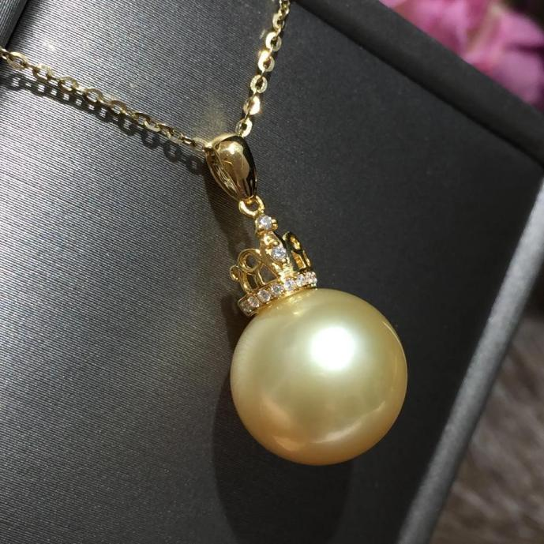
Figure 1 Nanyang golden pearl

3 The Development of Pearl Industry
3.1 The development and prosperity of ancient pearl trade
The ancient pearl trade was one of the important trading activities in human history, and it has had an important position from ancient times to the present day. Pearls were regarded as precious treasures in ancient times, with high value and symbolic significance. Therefore, the pearl trade prospered in ancient times and had an impact on the economy and culture of various regions around the world.

The pearl trade in ancient times was mainly concentrated in the East and the Middle East. As early as around 2000 BC, ancient Egypt had begun pearl trade. In ancient India and China, pearls were widely used and became symbols of nobility and royalty. During the Greek and Roman empires, pearls were also important trade commodities and were used for decoration and jewelry making. Among them, ancient pearl trade in China was particularly prosperous. As early as the Han Dynasty, China began maritime trade, and pearls became one of the important trade commodities. During the Tang Dynasty, the Chinese pearl industry reached its peak, and pearl trade became the main economic activity at the time. During the Tang Dynasty, Chinese pearls were mainly produced in Hainan Island, southern Fujian, Guangdong, and other places, among which the Jiangyao pearl from Guangdong was the most famous. Jiangyao pearl was known as the "sea gold" due to its bright color, high luster, and fine texture, and became the representative variety of pearl trade at that time.

As the pearl trade prospered, various pearl trade routes gradually formed. Among them, China's maritime trade route was one of the important routes for ancient pearl trade. In addition, the Persian Gulf, the Red Sea, and the Indian Ocean region also became important areas for ancient pearl trade. In the Indian Ocean region, Arab merchants once dominated the pearl trade and became the main transit station for pearl trade at that time.

The prosperity of ancient pearl trade not only promoted the economic development around the world but also promoted the exchange and integration of human culture. As an important trade commodity, pearls not only reflect people's yearning and pursuit for precious treasures but also become an important cultural heritage in human history.

3.2 The development of pearl craftsmanship
Pearl craftsmanship refers to the processing and production of various exquisite jewelry and crafts using pearls as the main raw material. With the passage of time, pearl craftsmanship has gone through different development stages in different historical periods.

3.2.1 Ancient pearl craftsmanship
In ancient times, pearl craftsmanship was mainly done by hand. As early as around 3000 BC, ancient Egyptians began using pearls to make jewelry and decorations. During the Greek and Roman empires, pearls were also widely used in the production of jewelry and decorations and became symbols of nobility and royalty.

Ancient pearl craftsmanship in China was also highly developed. During the Tang Dynasty, pearl craftsmanship in China reached its peak, and pearls were widely used in the production of various jewelry and decorations. Popular pearl craftsmanship at that time included pearl embroidery, pearl inlay, and pearl setting, among which the pearl inlay craftsmanship of Jiangyao pearls was the most famous. Pearl inlay craftsmanship was an important branch of ancient Chinese jewelry craftsmanship, which was widely used in the fields of court costumes, ceremonial dresses, and royal accessories (Figure 2). The Palace Museum in Beijing has a large collection of pearl inlay works, including pearl inlay robes, pearl inlay boots, and pearl inlay hats. One of the most famous pearl inlay works is a Qing Dynasty pearl inlay robe, which has exquisite and splendid pearl inlay patterns and is one of the masterpieces of Chinese pearl inlay craftsmanship. In the Tang Dynasty court painting "The Hundred Children," each child is dressed in gorgeous clothing, some of which have very beautiful pearl inlay patterns and lifelike, delicate designs. Pearl inlay works are exquisite and gorgeous, showcasing the superb skills and unique charm of ancient Chinese jewelry craftsmanship.
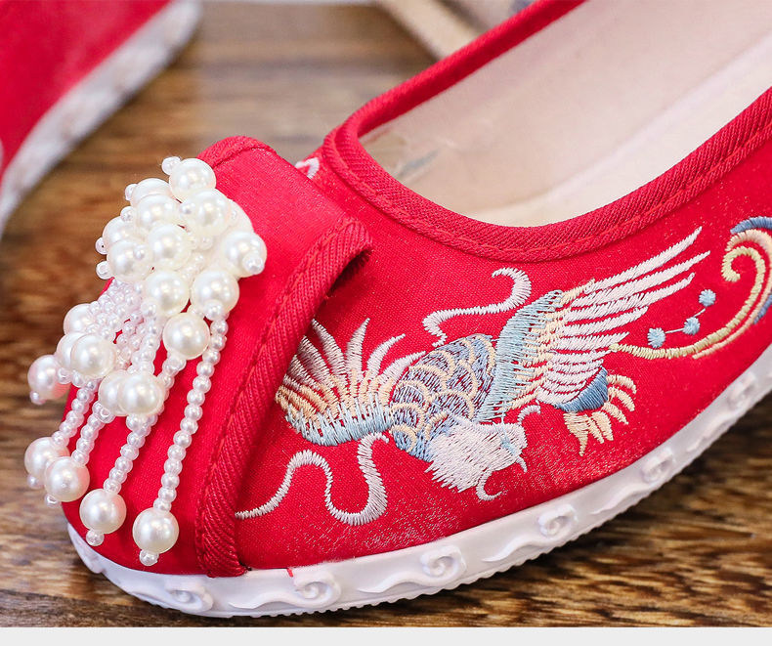
Figure 2 Embroidered shoes with bead embellishment technology

3.2.2 Modern pearl craftsmanship
With the development of industrialization and technology, pearl craftsmanship has gradually shifted towards mechanization and automation. At the beginning of the 20th century, Japan invented the pearl cultivation technology, which greatly increased the production of pearls and led to new developments in pearl craftsmanship. In modern times, pearl craftsmanship mainly includes fields such as jewelry design, jewelry making, pearl identification, and pearl maintenance.

In the field of jewelry design, pearls are widely used to create various high-end jewelry and accessories. Designers use innovative design concepts and exquisite craftsmanship to create pearl jewelry in various shapes and styles, showcasing the unique charm and value of pearls.

In the field of jewelry making, pearls are also widely used to create various high-end jewelry and accessories. Making pearl jewelry requires multiple steps, including drilling holes in the pearls, arranging them, and fixing them. The production process requires exquisite craftsmanship and meticulous manual work to ensure the quality and aesthetic level of pearl jewelry.

In the fields of pearl identification and pearl maintenance, pearl craftsmanship has also seen new developments. Pearl identification requires professional techniques and equipment to identify the quality and authenticity of pearls. Pearl maintenance requires a series of measures to protect the quality and aesthetic level of pearls.

Pearl craftsmanship has gone through different development stages in different historical periods. From ancient handcrafting to modern mechanical and automated production, pearl craftsmanship continues to innovate and develop, showcasing the unique charm and value of pearls.

4 Modernization and Development Trends of the Pearl Industry
4.1 The current state of the pearl industry
The pearl industry is a vast industry chain that includes pearl cultivation, processing, design, and sales. The market size of the pearl industry is enormous and involves multiple fields such as jewelry, accessories, and crafts. According to market research data, the global pearl market size reached around 20 billion US dollars in 2020 (Liang & Shi, 2017, Zhejiang Economy, 622(20): 50-51.). Among them, jewelry and accessories are the main markets of the pearl industry (Figure 3), accounting for nearly 70% of the total market.
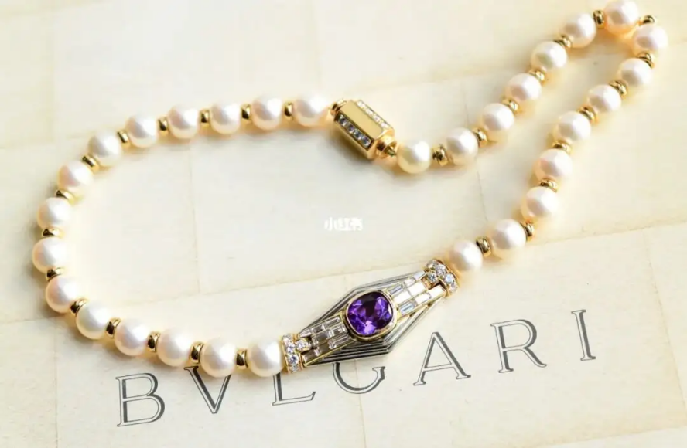
Figure 3 Bvlgari amethyst pearl bracelet

The consumer base for pearls is relatively broad, covering consumers of different ages, genders, incomes, and cultural backgrounds. On the one hand, as a traditional jewelry material, pearls are favored by older consumers. On the other hand, with the influence of fashion and trends, more and more young people are paying attention to pearl products, especially personalized and innovative pearl designs that are more likely to attract their attention. With the increasing demand for pearl products by consumers, the pearl industry is constantly developing and innovating, providing consumers with more diverse and personalized pearl products.

4.2 Research progress of pearls
Pearl research is a comprehensive study involving multiple disciplines, including physics, chemistry, biology, geology, and cultural studies. The formation mechanism of pearls is one of the core issues in pearl research (Bai et al., 2014). Currently, some progress has been made in the study of the formation mechanism of pearls. Research indicates that the interaction between Pinctada margartifera and the external environment is one of the important factors in pearl formation. In the future, research on the formation mechanism of pearls will continue to deepen, providing more scientific basis for pearl cultivation and the application of pearl materials.

In addition, there are multiple international pearl quality evaluation standards, among which the most representative one is the pearl quality evaluation standard developed by the International Pearl Association (CIBJO). It mainly includes the size, shape, luster, color, and surface quality of pearls. In addition, the color saturation, transparency, texture, and other factors are also important indicators for pearl quality evaluation. In addition to CIBJO, other organizations such as the Pearl Trade Association (PTA), the Pearl Research and Training Center (PRTC), and the Pearl Association of America (PAA) have also developed pearl quality evaluation standards. Although there may be slight differences between these standards, they overall reflect the main aspects of pearl quality evaluation.

Pearl processing technology is one of the important links in the pearl industry. Currently, pearl processing technology is relatively mature, but there is still a lot of room for improvement. In the future, research on pearl processing technology will continue to deepen in order to improve product quality and reduce production costs. At the same time, as a jewelry material, pearls have a wide range of applications. Currently, the use of pearl materials has covered multiple fields such as jewelry, accessories, and crafts. In the future, with changes in market demand and technological advancements, the application of pearl materials will become more diverse and personalized (Xu, 2012, Scientific Fish Farming, 270(2): 4-6.).

Pearl culture is also an important aspect of pearl research. In many traditional cultures, pearls are considered precious items that represent power, wealth, and prestige. For example, in ancient China, pearls were used as decorations by the imperial family and nobility, symbolizing status and wealth. In Hindu culture, pearls are believed to be the tears of the moon god, representing purity and wisdom. In Japan, pearls are known as the "gem of the sea" and are regarded as a symbol of happiness and longevity. Pearls are widely used in jewelry making and are an essential element of jewelry art. The round luster and unique color of pearls make them precious materials for jewelry designers, who can combine them with materials such as gold, silver, and diamonds to create unique jewelry works. Many famous jewelry brands have made pearls their flagship products and have launched many creative and design-oriented pearl jewelry pieces, which are loved by fashion enthusiasts. Pearls also appear in many works of art, such as paintings, sculptures, and installation art. Famous artists often use pearls to create unique works of art, making them an important element of art.

4.3 The importance of the pearl industry
The importance of the pearl industry has been reflected in the aspects of economy, culture, society, and ecological conservation. The development of the pearl industry can not only promote economic prosperity and cultural inheritance, but also contribute to ecological conservation and international exchange.

The pearl industry is a huge industry chain, including pearl cultivation, processing, design, sales, and other links. The global pearl market size is around billions of US dollars, and the pearl industry has made significant contributions to global economic development (Zhu et al., 2023). At the same time, the pearl industry has brought employment opportunities and economic benefits to pearl-producing regions. Pearls are a jewelry material with rich cultural connotations, with a long history and profound cultural heritage. In the development of the pearl industry, some traditional pearl cultivation techniques and crafts have been preserved and inherited, and pearl culture has been widely disseminated and promoted. The development of the pearl industry has also driven international exchanges and cooperation. Learning and cooperation between different countries and regions in the pearl industry have promoted the development and innovation of the pearl industry. Therefore, pearl products have become a way of communication and exchange between different cultures.

The pearl industry also plays an important role in ecological conservation. Some pearl cultivation enterprises adopt environmentally friendly cultivation techniques to promote the sustainable development of the pearl industry. At the same time, the pearl industry also has a certain role in protecting natural environments such as coral reefs.

4.4 Sustainable development of pearls
Traditional pearl cultivation usually uses the marine environment, which can have an impact on the ecological environment. In the future, pearl cultivation may adopt more environmentally friendly and sustainable methods, such as land-based cultivation or underwater cultivation, to reduce the impact on the marine environment while lowering the cost of pearl cultivation. At the same time, pearl processing usually generates a large amount of wastewater, waste residue, etc., causing environmental pollution. In the future, pearl processing may adopt more environmentally friendly technologies, such as biodegradation technology, green solvents, etc., to reduce the impact of pearl processing on the environment (Zou, 2023).

Pearls are a high-value natural resource that can be applied to fields such as jewelry and crafts. In the future, pearls may be more widely reused, such as redesigning jewelry, remaking crafts, etc., to reduce the waste of pearl resources. Moreover, pearls contain a large amount of calcium elements, which can be applied to the restoration of water and soil. In the future, pearls may be more widely used in the field of environmental restoration to reduce the impact of pollutants on the environment. With people's increasing emphasis on environmental protection, the environmental image of pearl brands has become increasingly important. In the future, pearl brands may pay more attention to the image and value of environmental protection and sustainable development, thus gaining more recognition and support from consumers.

5 Summary and Outlook
The charm of pearls exists in every corner of the world at all times. Since the beginning of recorded history, pearls have been metaphorically described as the embodiment of virtues, love, wisdom, justice, spirituality, and fairness. Pearls have always been regarded as priceless treasures and are considered the symbol of all gems. Great poets of every era have written poems praising pearls. From ancient China, India, Persia, Egypt, Greece, and Rome, to the Maya, Aztec, and Inca cultures of the Americas, even the ancient cultures of the South Pacific and Australia, without exception, express their admiration for pearls.

Pearls are an ancient and mysterious gemstone, with a history that can be traced back several thousand years. With the development of human civilization over thousands of years, as well as the continuous progress of technology and the development of international trade, the pearl industry has also been constantly developing and growing. The modern pearl industry not only includes pearl cultivation and processing but also includes aspects such as pearl sales and marketing. The pearl industry plays an important role in many countries and regions, providing significant support to the local economy and employment. At the same time, as a cultural and artistic item, pearls also bring great impetus to the local cultural and tourism industries.

The future development trend of the pearl industry will be technological, environmentally sustainable, diversified, international, and innovative. The pearl industry will continue to introduce more diversified and high-quality pearl products, continuously meet the needs and preferences of consumers, and promote the development of the pearl industry. At the same time, research on the physical and chemical properties of pearls, biology and genetics, cultural and social significance, etc., can provide better support and help for the development of the pearl industry. In the future, with the continuous progress of technology and innovation, the development and innovation of the pearl industry will be faster and more extensive. Moreover, more research will deepen our understanding of pearls, providing important support and guidance for better utilization and protection of pearl resources.

Authors' Contributions
Zhu Di is the main author of the review, responsible for collecting and analyzing relevant literature materials, writing the initial draft of the paper, and participating in the analysis and organization of literature materials. Jin Lingfei is the project ideator and leader, guiding the writing of the paper. All authors have read and agreed to the final text.

Acknowledgements
This review was supported by the Cuixi Innovation Research and Development Project Fund of Zhuji Cuixi Biotechnology Research Institute. The illustrations in this review are from the internet, and we would like to thank the creators of these images for their support. We respect and uphold the rights of each image owner.

References
Bai Z.Y., Wang G.L., Liu X.J., and Li J.L., 2014, The status and development trend of freshwater pearl seed industry in China, Shanghai Haiyag Daxue Xuebao (Journal of Shanghai Ocean University), 23(6): 874-881.
Sha N.L., and Zhang X.H., 2013, Pearls,Geology Press, Beijing, China, pp.38-48.
Zhang B.L., 2006, Systematic gemmology, Geology Press, Beijing, China, pp.102.
Zhu S.H., Jiang S., Zhou S.Y., Jia R., Li T.Y., and Zhou C., 2023, Research and analysis of pearl market in Jiangsu and Zhejiang, Xiandai Shangye (Modern Business), 670(9): 101-105.
Zou X.G., Fei J.Y., Hao G.J., Zeng Z.G., Wang Y., Yu Y.D., Ruan H.J., Yang K., and Sun P.L., 2023, Progress in extraction, isolation, bioactivity, and applications in the field of nutrition and health of pearl and pearl oyster meat protein peptides, Shipin Gongye Keji (Science and Technology of Food Industry), 44(12): 455−460.

